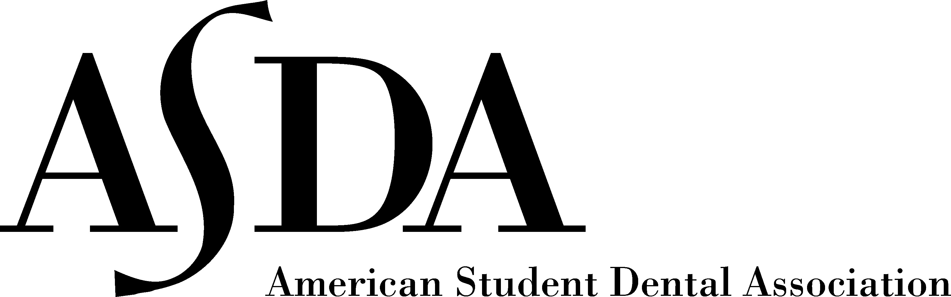

First Year Events Coordinator

Position Description
First year events coordinator representative is responsible for planning the Lunch & Learns during the Spring and assisting the 2nd year events coordinator and chair with their responsibilities as well.

Goals
Maintain positive and professional relationships with vendors.
Strive to make new contacts at various vendor fairs, meetings, conferences, and any other events where networking may be done.
Communicate well with each other and keep a running list of contacts.

Position Tasks
- Plan Lunch and Learns during the Spring Semester
  - Invite vendors at the beginning of each semester
  - Inform vendors of the process and be available for questions
  - Reserve rooms for Lunch & Learns- fill out the solicitation form to send to Senior Support Assistant of Office of Student and Alumni Affairs.
  - The Events Coordinator may also plan events similar to Lunch & Learns to be held outside of the dental school not during school hours.
- Send out mass email reminders for Lunch & Learns
- Ensure a summary is written for each event planned for records/Golf Crown Award application
- Ordering food and beverages for the Vendor Fair in the Spring

Events Committee Tasks
- Have the knowledge to recommend certain vendors to ASDA officers when they are looking for sponsors.
- Present or make the chapter officers and members aware of resources for fundraising opportunities.
- Help put other ASDA officers into contact with vendors when necessary
- Check and correspond with vendors using the gmail account for the Events Coordinator. (ASDAHoustonEvents@gmail.com)
- Attend all lunch and learns and off campus events unless there is a conflict and those in the events committee are aware of the conflict
- Vendor Fair is mandatory for everyone in the events committee.
- The events committee must work together with the overall goal of bettering the Houston ASDA chapter.

Officer Requirements
- All officer meetings and committee meetings (specific for job title) are mandatory.
- Officers are encouraged attend ASDA Lunch & Learns and ASDA hosted events.
- Serve as an association content expert to be a resource to ASDA members.
- Officers are encouraged to write at the local and national level on topics for their job title.
- Document important resources and information to be used for Gold Crown Award and continuity for future officers.
- Regularly update Webmaster with event photos and video following events.
- Be available as needed for any and all chapter related business outside of your normal duties.

- Assist predecessors in the position during the transition between years.
- Officers should follow all rules of UTSD. Leaders should be held to a higher standard than the general body.

Officer Agreement

As a chapter leader of the Houston ASDA and a member of the dental profession, I agree to abide by this pledge and its stipulations:

I understand and fully accept my responsibilities as a chapter leader of this Association. I am aware of and shall always strive for the betterment of this Association and the future of the profession of dentistry. As a professional, I commit myself to self-improvement and lifelong learning, acknowledging that my competence in all endeavors depends on the continual attainment of knowledge and the improvement of skills. I acknowledge my obligation to uphold the honor and integrity of the Association and profession, and to always conduct myself in a manner deserving of the respect of my fellow members, colleagues, national leaders, patients and community.

All this I pledge with pride in my commitment to the American Student Dental Association, the profession of dentistry, and the public we serve.

I understand and willingly agree to fulfill the following responsibilities:
- Comply with Houston ASDA’s Bylaws and policies
- Work diligently to fulfill the responsibilities of each elected or appointed leadership position I hold
- Conduct all personal and professional activities with honesty, integrity, respect, fairness and good faith in a manner that will reflect good credit upon the profession of dentistry and Houston ASDA
- Avoid the use of elected and appointed positions in Houston ASDA for personal gain
- Refrain from participating in any activity that demeans the credibility and dignity of any professional peer; general member, fellow officer or Houston ASDA itself
- Refrain from action or communications which would lead members or other publics to unrealistic expectations about Houston ASDA
- Accept no gifts or benefits offered with the expectation of influencing a decision when conducting Association business

__________ I accept this Chapter Leadership position. By doing so, I agree to the stipulations outlined in this document.

__________ I do not accept this Chapter Leadership position.

Signature: ______________________________________________ Date: ____________________

